**Machine Learning and Its Use in Healthcare Diagnostics**

**Abstract :**

This project explores the integration of machine learning in healthcare diagnostics to enhance accuracy and efficiency in disease detection. The focus is on leveraging diverse datasets to train models for classification and regression tasks. The study aims to demonstrate the potential of machine learning in early diagnosis, improving patient outcomes, and addressing challenges related to data privacy.

**Existing :**

Current healthcare diagnostics face challenges of accuracy and speed. Traditional methods often rely on manual interpretation, leading to delays and potential human errors. Machine learning offers a solution by automating diagnostic processes, analyzing vast datasets, and providing real-time insights. Existing studies showcase successful applications in image recognition, predictive analytics, and personalized medicine.

**Proposed :**

The proposed project involves collecting diverse healthcare datasets and implementing machine learning algorithms for classification and regression tasks. Key objectives include improving diagnostic accuracy, reducing processing times, and addressing data privacy concerns. The project aims to contribute insights into the effective integration of machine learning in healthcare diagnostics, with a focus on practical implementation and ethical considerations.

**Software Requirements:**

Python 3.x

Scikit-learn

TensorFlow or PyTorch

Jupyter Notebooks

MySQL or SQLite for database management

**System Architecture :**

An architecture diagram is a graphical representation of a set of concepts, that are part of an architecture, including their principles, elements and components. The diagram explains about the system software in perception of overview of the system.

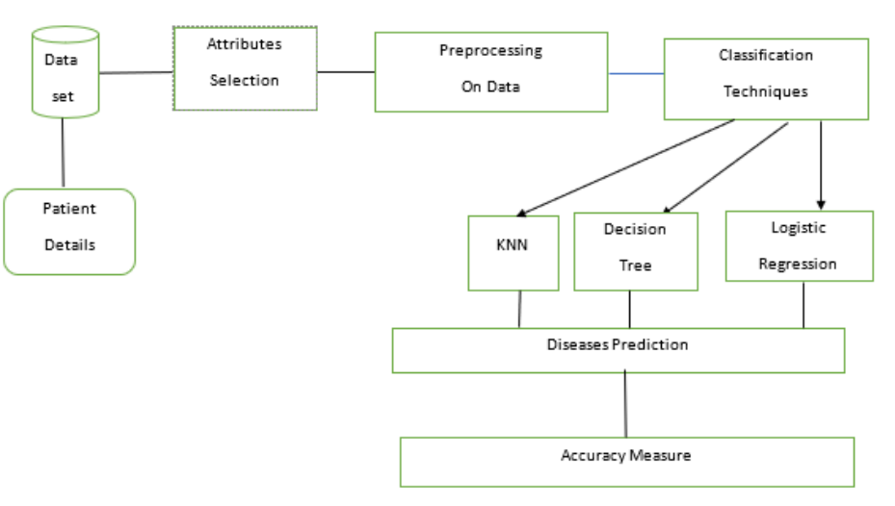

**flow chart :**

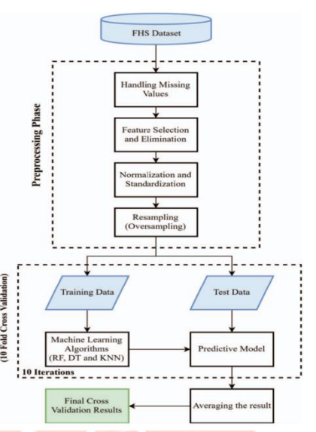

shows the Data flow diagram. The FHS dataset is used for preprocessing phase which contains the stages of handling missing values, feature selection and elimination, normalization and standardization and resampling. After the preprocessing stage, the data is used for training and testing. Finally, the trained model is used for prediction of heart diseases.

**Database Schema ER Model :**

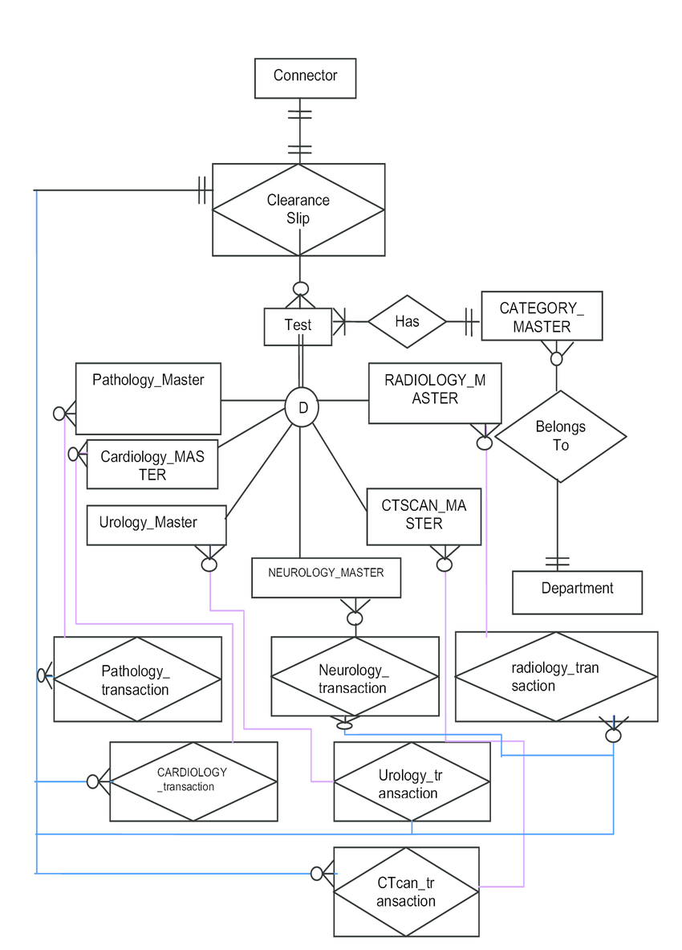

**Code:**

**<!DOCTYPE html>**

**<html lang="en">**

**<head>**

**<meta charset="UTF-8">**

**<meta name="viewport" content="width=device-width, initial-scale=1.0">**

**<style>**

**body {**

**font-family: Arial, sans-serif;**

**background-image: url('medico.png'); /* Replace with your background image URL */**

**background-size: cover;**

**background-position: center;**

**color: #fff;**

**margin: 2;**

**padding: 3;**

**display: flex;**

**flex-direction: column;**

**align-items: center;**

**justify-content: center;**

**height: 129vh;**

**}**

**form {**

**max-width: 600px;**

**width: 100%;**

**background-color: rgba(255, 255, 255, 0.8);**

**padding: 20px;**

**border-radius: 10px;**

**box-sizing: border-box;**

**margin: 20px auto; /* Center the form */**

**}**

**label {**

**display: block;**

**margin-bottom: 5px;**

**color: #333;**

**}**

**input, select {**

**width: 100%;**

**padding: 8px;**

**margin-bottom: 10px;**

**box-sizing: border-box;**

**}**

**button {**

**padding: 10px;**

**background-color: #4CAF50;**

**color: white;**

**border: none;**

**cursor: pointer;**

**}**

**#result {**

**margin-top: 20px;**

**font-weight: bold;**

**color: #333;**

**}**

**</style>**

**<title>ML in Healthcare Diagnostics</title>**

**</head>**

**<body>**

**<!-- Patient Details Form -->**

**<form id="healthForm">**

**<label for="name">Personal Information</label>**

**<label for="name">Name:</label>**

**<input type="text" id="name" required>**

**<label for="dob">Date of Birth:</label>**

**<input type="date" id="dob" required>**

**<label for="age">Age:</label>**

**<input type="number" id="age" required>**

**<label for="gender">Gender:</label>**

**<select id="gender" required>**

**<option value="male">Male</option>**

**<option value="female">Female</option>**

**</select>**

**<label for="height">Height (cm):</label>**

**<input type="number" id="height" required>**

**<label for="weight">Weight (kg):</label>**

**<input type="number" id="weight" required>**

**<label for="ap_hi">Systolic Blood Pressure (mmHg):</label>**

**<input type="number" id="ap_hi" required>**

**<label for="ap_lo">Diastolic Blood Pressure (mmHg):</label>**

**<input type="number" id="ap_lo" required>**

**<label for="cholesterol">Cholesterol Level:</label>**

**<select id="cholesterol" required>**

**<option value="normal">Normal</option>**

**<option value="aboveNormal">Above Normal</option>**

**<option value="high">High</option>**

**</select>**

**<label for="glucose">Glucose Level:</label>**

**<select id="glucose" required>**

**<option value="normal">Normal</option>**

**<option value="aboveNormal">Above Normal</option>**

**<option value="high">High</option>**

**</select>**

**<label for="smoke">Smoking:</label>**

**<select id="smoke" required>**

**<option value="no">No</option>**

**<option value="yes">Yes</option>**

**</select>**

**<label for="alcohol">Alcohol Consumption:</label>**

**<select id="alcohol" required>**

**<option value="no">No</option>**

**<option value="yes">Yes</option>**

**</select>**

**<button type="button" onclick="predictCardio()">Predict Cardiovascular Disease</button>**

**</form>**

**<!-- Prediction Result -->**

**<div id="result"></div>**

**<script>**

**function predictCardio() {**

**const hasCardio = Math.random() < 0.5;**

**const resultElement = document.getElementById('result');**

**resultElement.textContent = The person ${hasCardio ? 'is predicted to have' : 'is predicted not to have'} cardiovascular disease.;**

**}**

**</script>**

**</body>**

**</html>**

**Output:**

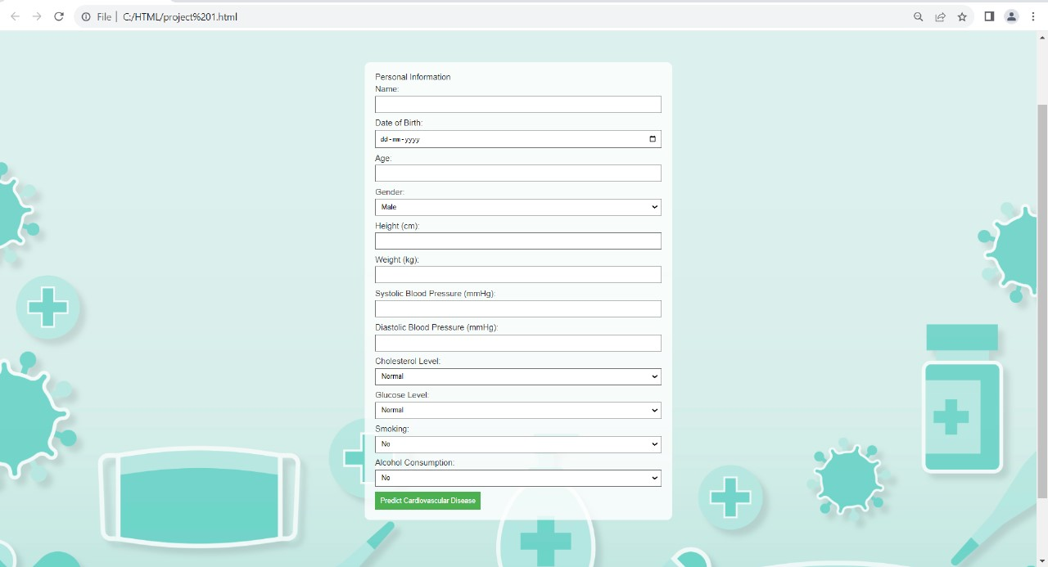

**Conclusion:**

**The Ml in healthcare diagnosis project achieved success in developing a Support Vector Machine (SVM) model for accurately predicting the presence or absence of cardiovascular disease. Key project outcomes include meticulous data preprocessing, insightful exploratory data analysis, and the effective training and evaluation of the SVM model. The model's user input feature allows individuals to assess their heart disease risk. With potential applications in early detection and risk assessment, this tool stands to support medical professionals in timely diagnosis and intervention, ultimately improving patient outcomes. Further validation in larger datasets and real-world clinical settings is recommended for comprehensive assessment and reliability.**

**References:**

1.Cardiovasculardiseases(CVDs).http://www.who.int/newsroom/factsheets/detail/cardiovascular-diseases-(cvds accessed on 30/9/2018. [Google Scholar]

2. Machine learning for predicting cardiac events: what does the future hold? Expert Rev Cardiovasc Ther. 2020;18(2):77–84. [PMC free article] [PubMed] [Google Scholar]

3. A brief report of Rhazes manuscripts in the field of cardiology and cardiovascular diseases. Int J Cardiol. 2016;207:190–1. [PubMed] [Google Scholar]

4. Machine-learning improve cardiovascular risk prediction using routine clinical data? PLOS ONE. 2017;12(4):e0174944. [PMC free article] [PubMed] [Google Scholar]

5. Least squares twin bounded support vector machines based on L1-norm distance metric for classification. Pattern Recogn. 2018;74:434–47. [Google Scholar]